**A.A.GOVERNMENT ARTS COLLEGE, MUSURI.**

**Affiliated to Bharathidasan University, Tiruchirappalli.**

**NAAN MUDHALVAN PROJECT- III B.SC MATHEMATICS**

**SUBSCRIBERS GALORE: EXPLORING WORLD’S TOP YOUTUBE CHANNELS**

**Submitted by:**

**TEAM ID: NM2023TMID08464**

**TEAM LEADER: PATTATHI D [97FCAA0AFC96D778A0A4DADB0CAA0EAF]**

**MEMBER 1: NAVEEN R [783A8DB26BB5841BDCF4745C7D66F29A]**

**MEMBER2: MUKESH KANNA S [B75F20714237637AFB4440D054ACCDC3]**

**MEMBER3: PRASANTH N [F20BD9013E907C69D0B4FC376E10D434]**

**MEMBER4: PRAKASH S [AE94EB3E2F0ECDD8FBC4544220C44B6E**]

**INTRODUCTION:**

* A subscriber to a channel on the video-sharing YouTube is a user who has chosen to receive the channel's content by clicking on that channel's "Subscribe" button, and each user's subscription feed consists of videos published by channels to which the user is subscribed. The ability to subscribe to users was introduced in October 2005. YouTube began publishing a list of its most-subscribed channels in April 2006. An early archive of the list dates to May 2006.
* The following table lists the 50 most-subscribed YouTube channels, as well as the primary language and content category of each channel. The channels are ordered by number of subscribers; those whose displayed subscriber counts are identical are listed so that the channel whose current growth rate indicates that its displayed subscriber count will exceed that of the other channel is listed first.
* Automatically generated channels that lack their own videos (such as Music and News) and channels that have been made effectively obsolete as a result of the transferal of their content (such as Justin Bieber VEVO and Taylor Swift VEVO) are excluded. As of February 2023, 21 of the 50 channels listed primarily produce content in English while 16 primarily produce content in Hindi. All 50 of the channels have surpassed 40 million subscribers, 39 of them have surpassed 50 million subscribers, 23 of them have surpassed 60 million subscribers, 16 of them have surpassed 70 million subscribers, 12 of them have surpassed 80 million subscribers, 10 of them have surpassed 90 million and 7 of them have surpassed 100 million subscribers. Only 1 channel (T-Series) has surpassed 200 million subscribers.

Milestone 1: Define Problem / Problem Understanding

**Activity 1: Empathy map**

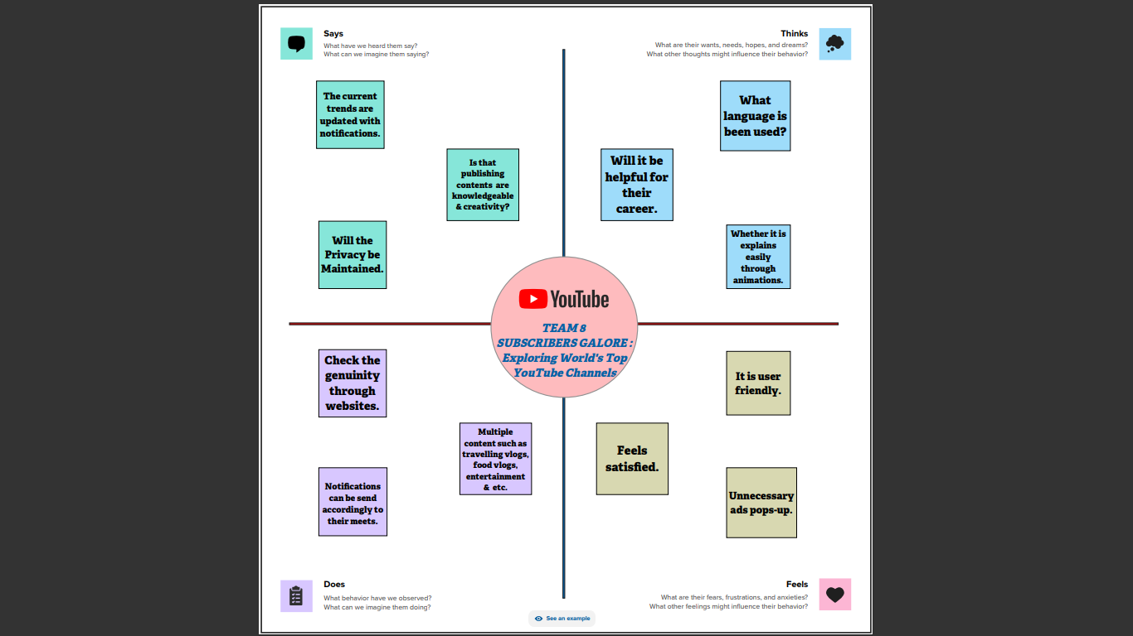

**Activity 2: Requirement: (Brain Strom)**

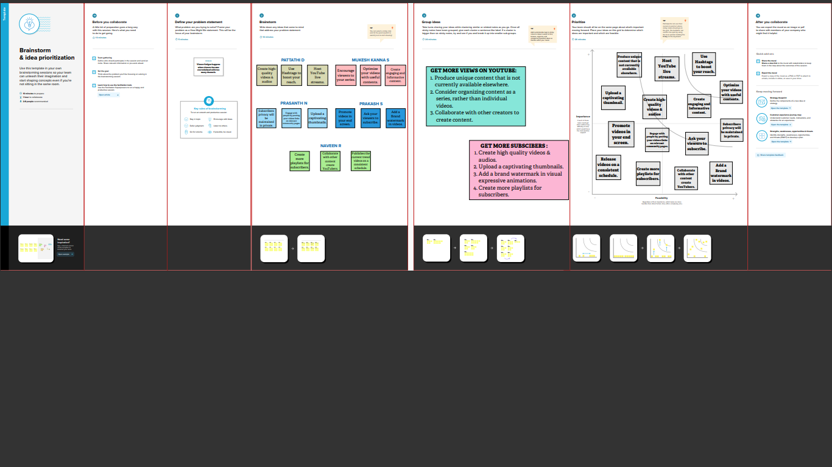

**REFERENCES:**

* *Stegner, Ben. "The Top 10 Most Popular YouTube Channels: Should You Subscribe?" (https://web.archive.org/web/2018032621 4229/https://www.makeuseof.com/tag/mo st-popular-youtube-channels/) . MakeUseOf. Archived from the original (htt ps://www.makeuseof.com/tag/most-popul ar-youtube-channels/) on March 26, 2018. Retrieved November 30, 2018.*
* *"T-Series Rules YouTube's Airwaves, but Bhushan Kumar Is Not Stopping Here" (http s://web.archive.org/web/2017012606193 3/http://economictimes.indiatimes.com/m agazines/panache/t-series-rules-youtubesairwaves-but-bhushan-kumar-is-not-stoppin g-here/articleshow/56748220.cms) . The Economic Times. Bennett, Coleman & Co. Archived from the original (https://economi ctimes.com/magazines/panache/t-series-r ules-youtubes-airwaves-but-bhushan-kumar -is-not-stopping-here/articleshow/5674822 0.cms) on January 26, 2017. Retrieved December 3, 2018.*
* *"YouTube - Most Subscribed Channels" (htt ps://web.archive.org/web/2006070319571 8/https://www.youtube.com/members?m s) . YouTube. July 3, 2006. Archived from the original on July 3, 2006. Retrieved September 11, 2016.*

**Milestone 2:** **Data Collection &Extraction:**

**Activity 1: Collect the Dataset:**

Please use the link to download the dataset:

<https://www.kaggle.com/datasets/rajkumarpandey02/list-of-most-subscribed-youtube-channels-in-world>

**Activity 1.1: Understand the data**

List of most-subscribed YouTube Channels.csv

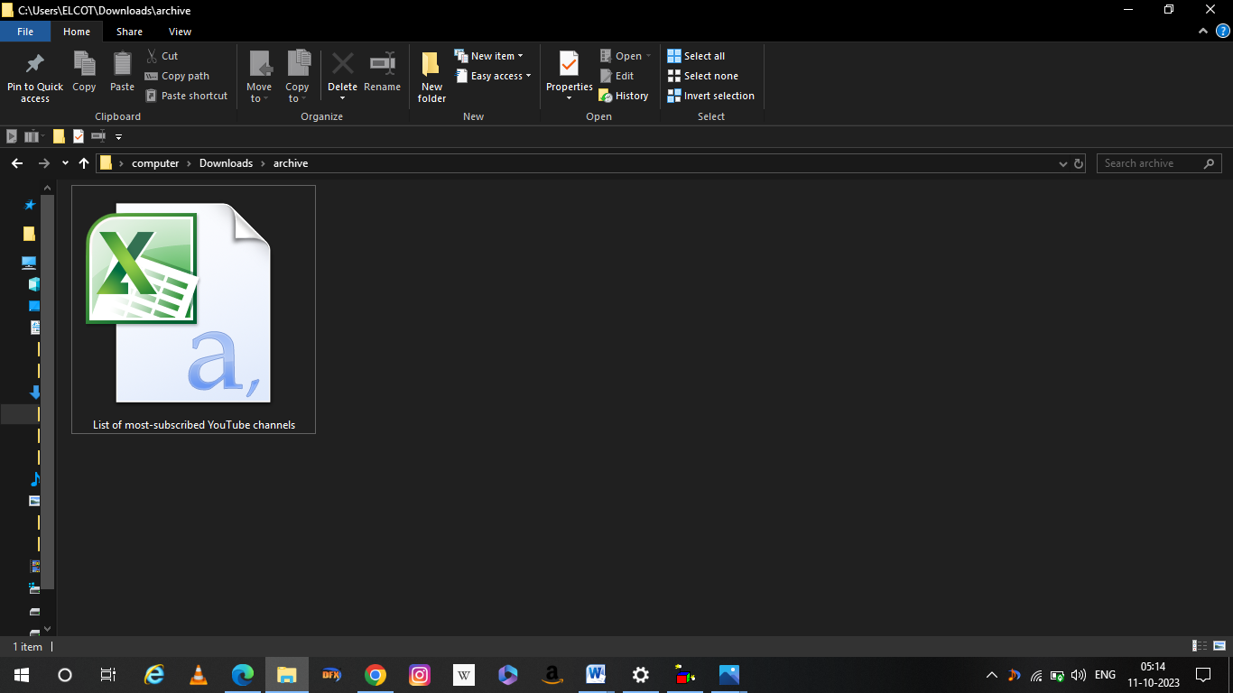

**Column description**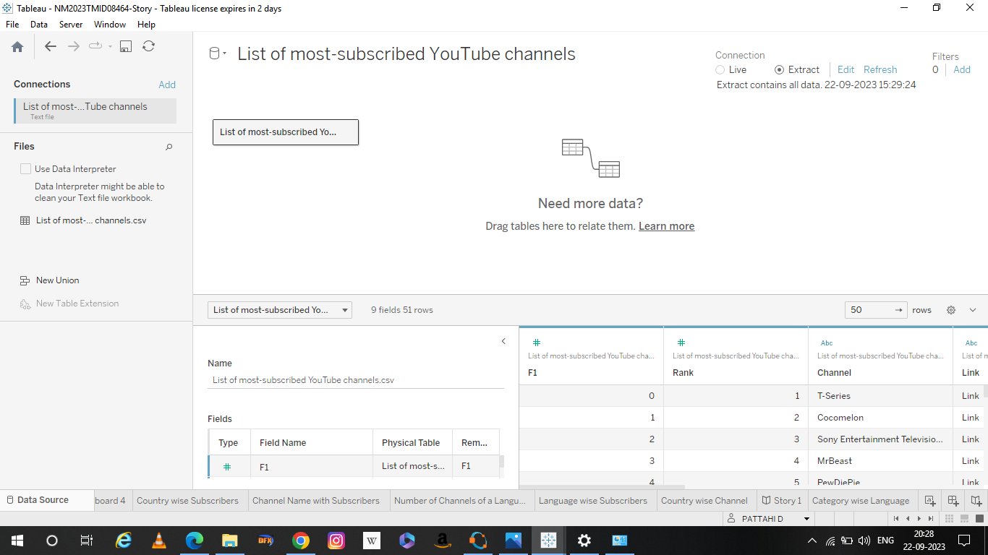

**Activity 2: Connecting to Tableau:**

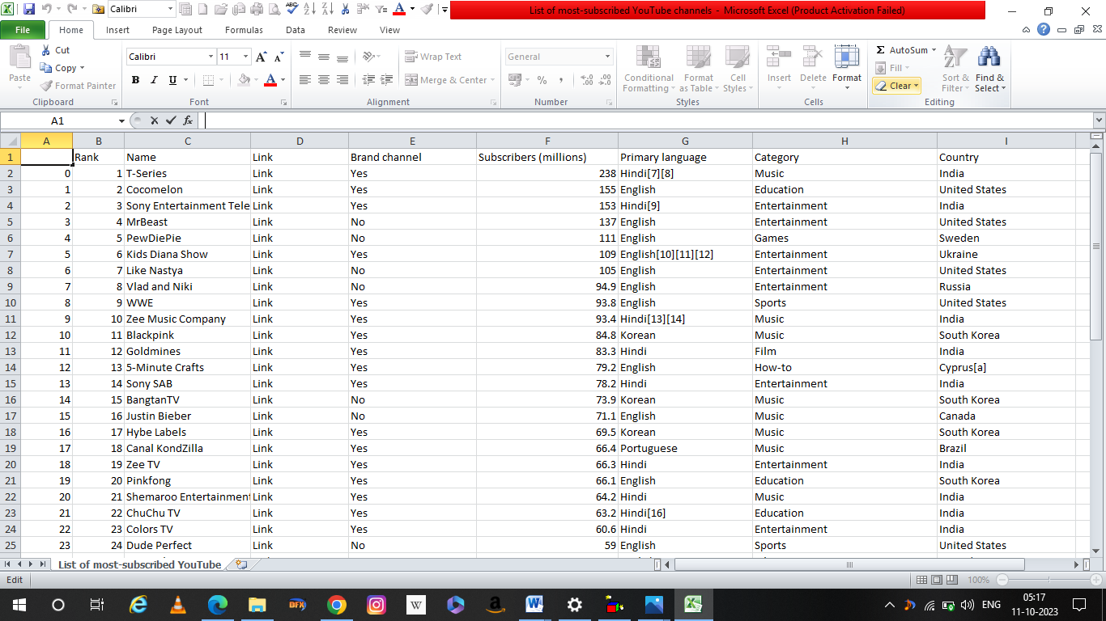

**Milestone 3:** **Data Preparation**

* Preparing the data for visualization involves cleaning the data to remove irrelevant or missing data, transforming the data into a format that can be easily visualized, exploring the data to identify patterns and trends, filtering the data to focus on specific subsets of data, preparing the data for visualization software, and ensuring the data is accurate and complete. This process helps to make the data easily understandable and ready for creating visualizations to gain insights into our analysis.

**Milestone 4**: Data Visualization

**Activity: 1--No of Unique Visualizations**

These visualizations can be used to compare performance, track changes over time, show distribution, and relationships between variables.

**Activity 1.1:**

Rank wise Channel 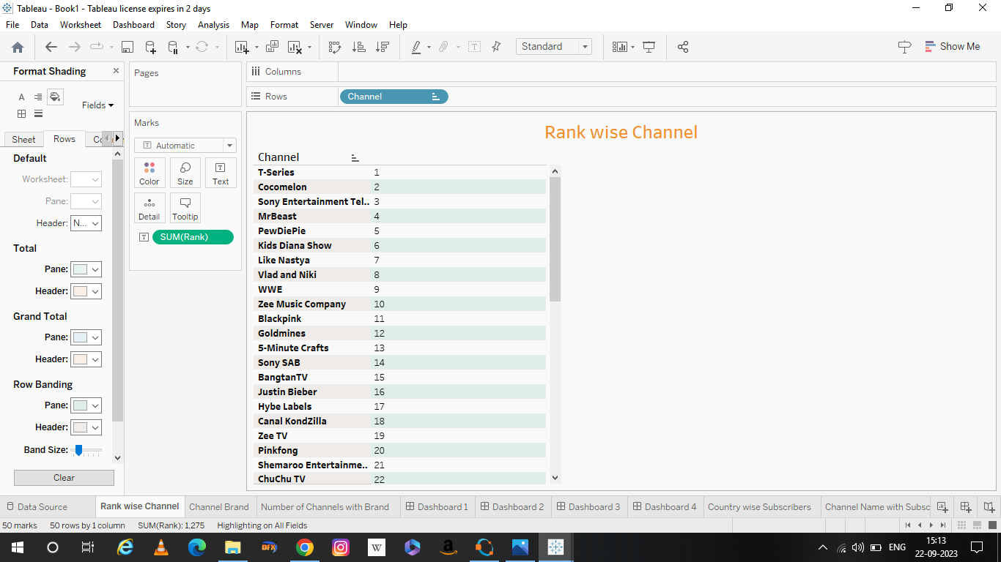

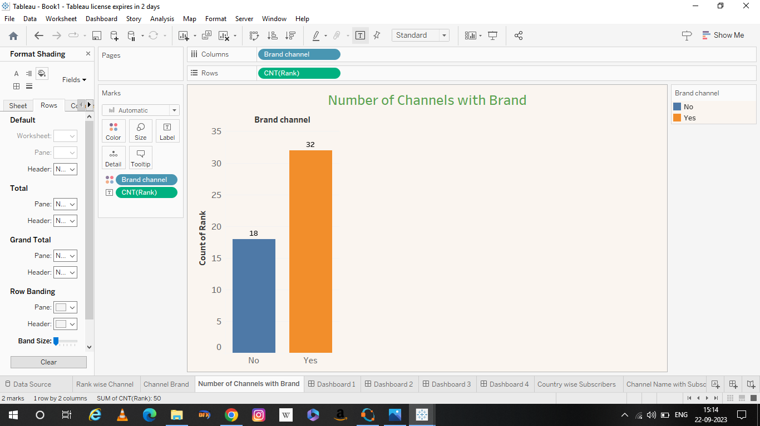**No of Channels with Brand**

**Channel Brand**

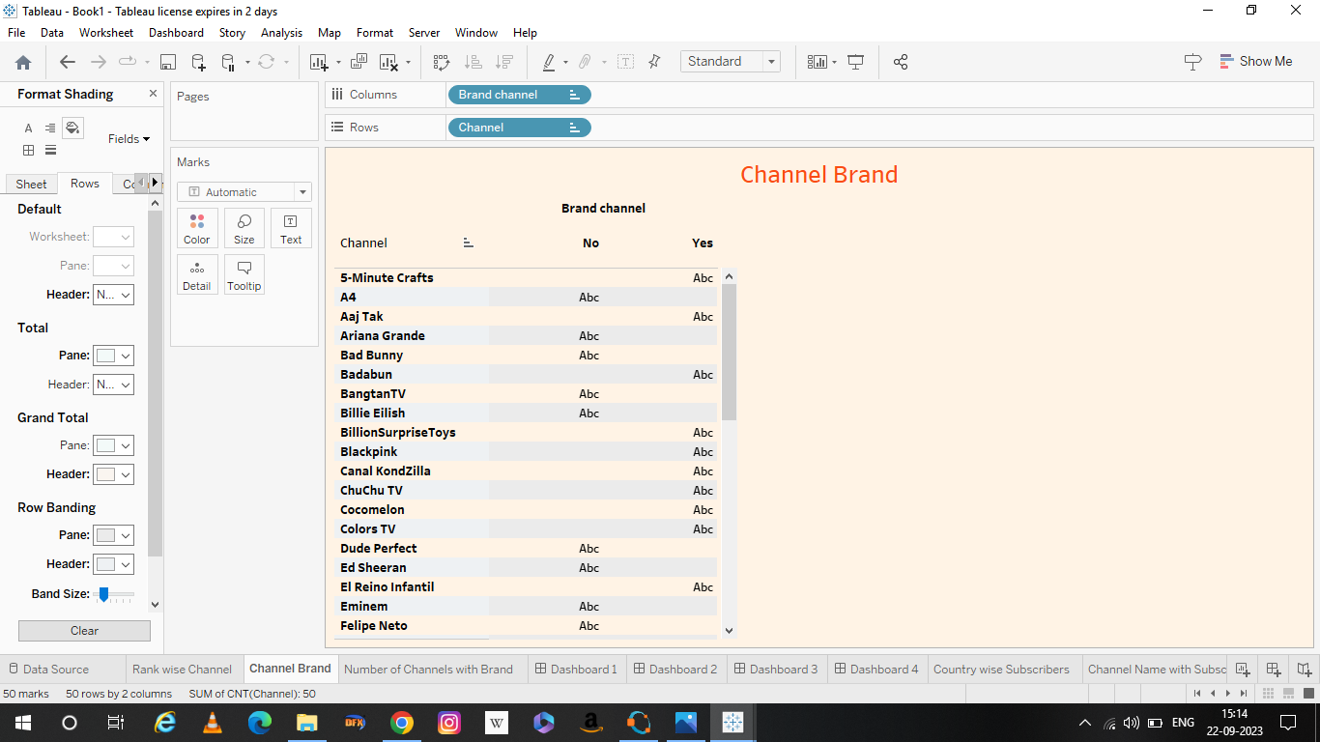

**Activity 1.2:**

**Channel Name with Subscribers**

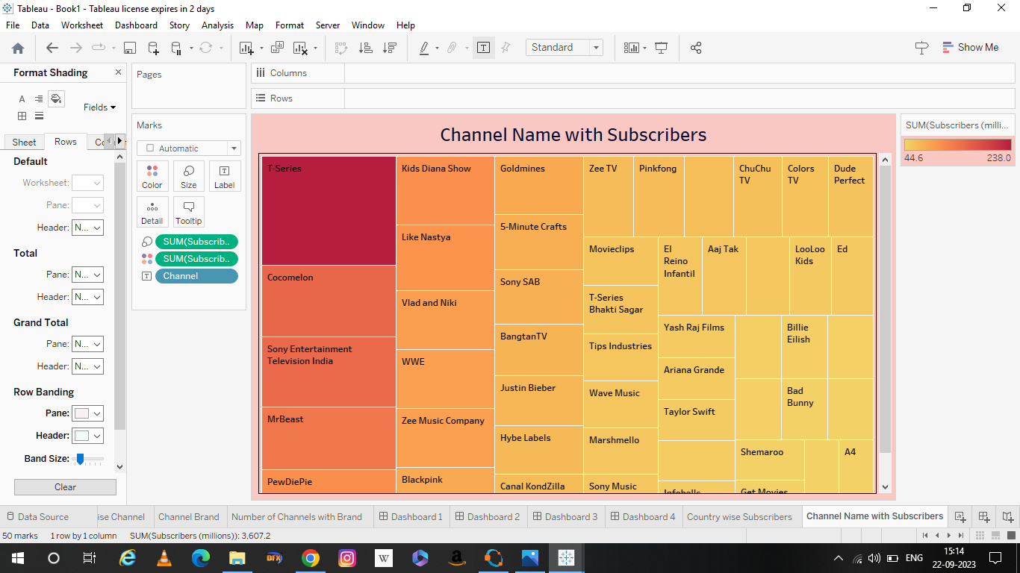

**No of Channels for particular language**

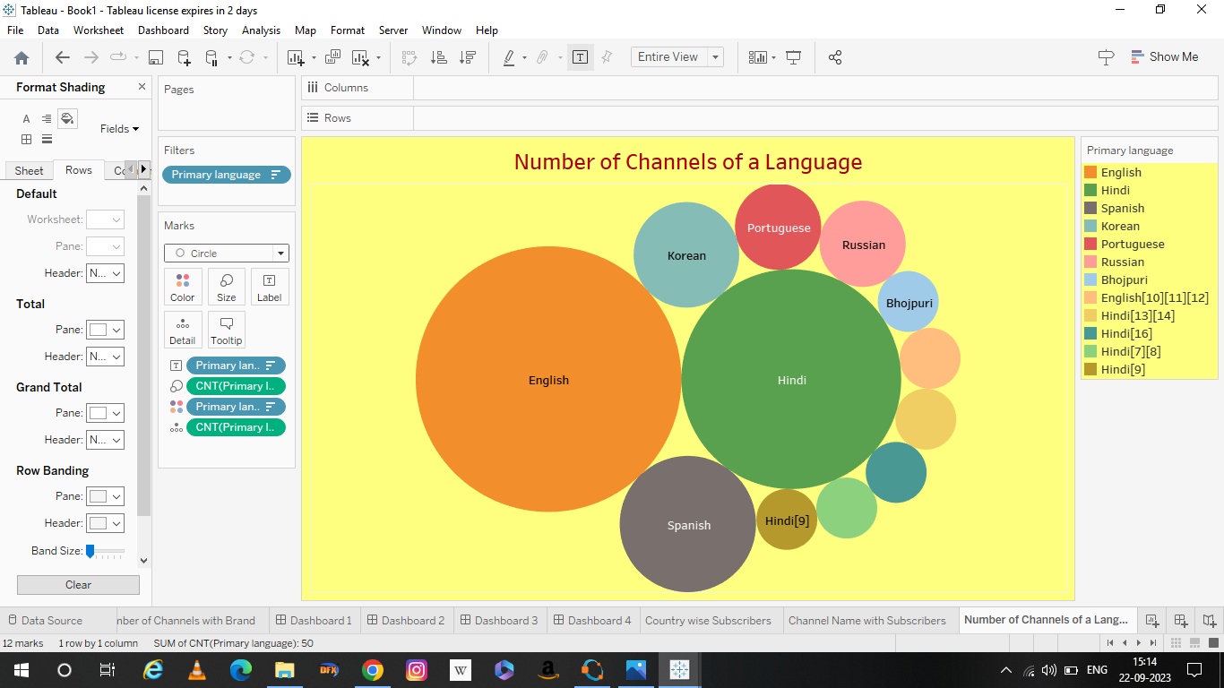

**Activity 1.3:**

**Country wise subscribers**

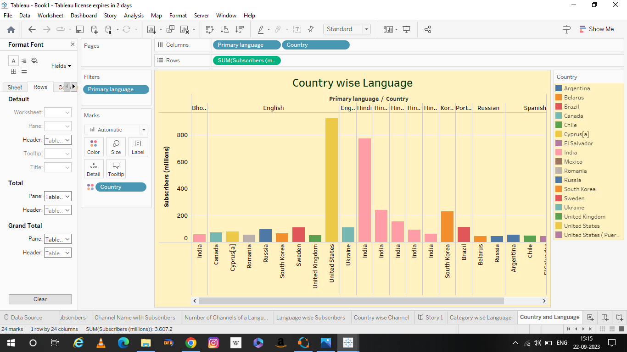

Language wise subscribers

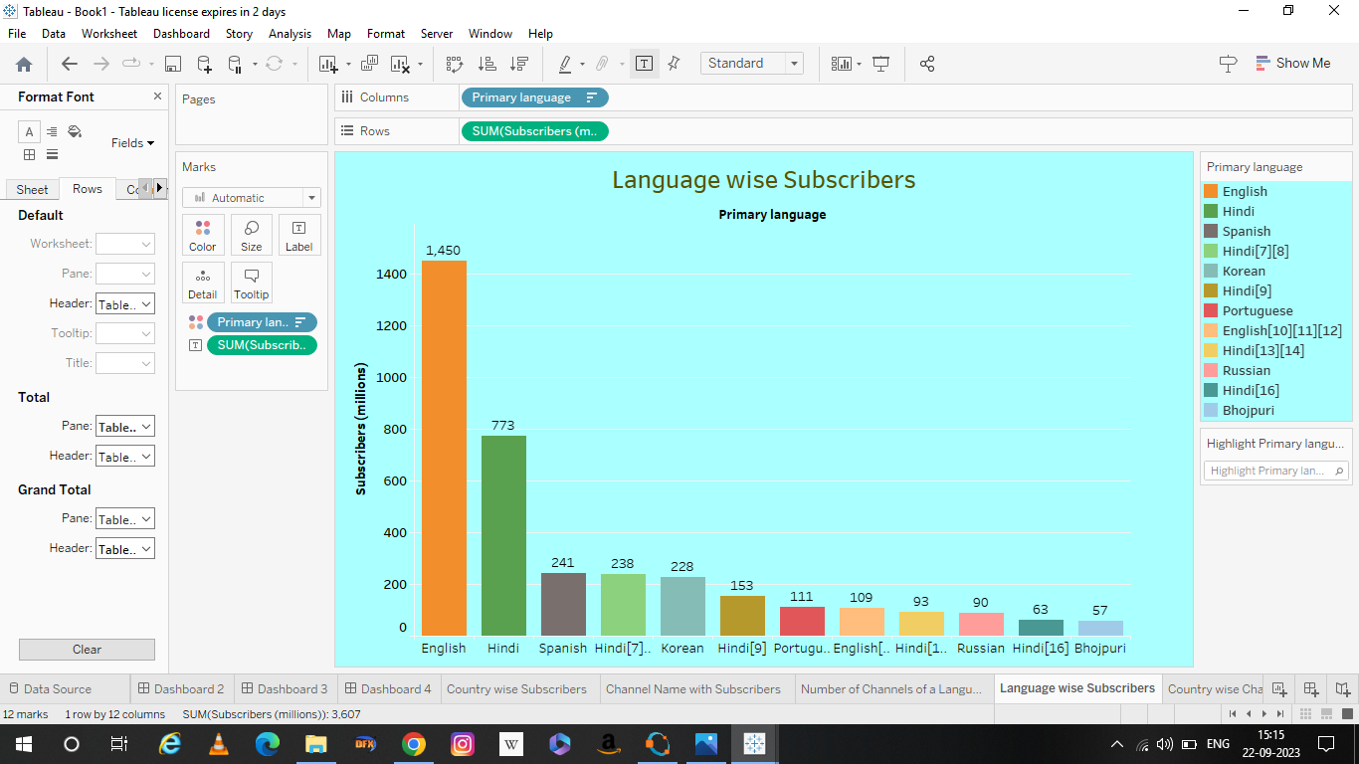

**Activity 1.4:**

**Country wise Channel**

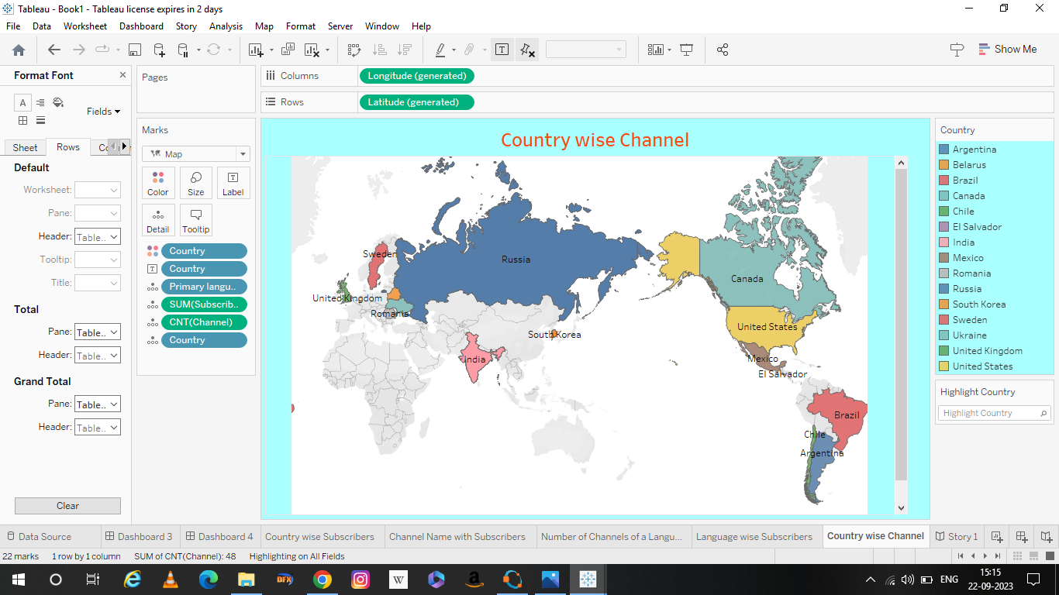

**Milestone 5:** **Dashboard**

**Activity 1: Responsive and Design of Dashboard**

Dashboard 1:

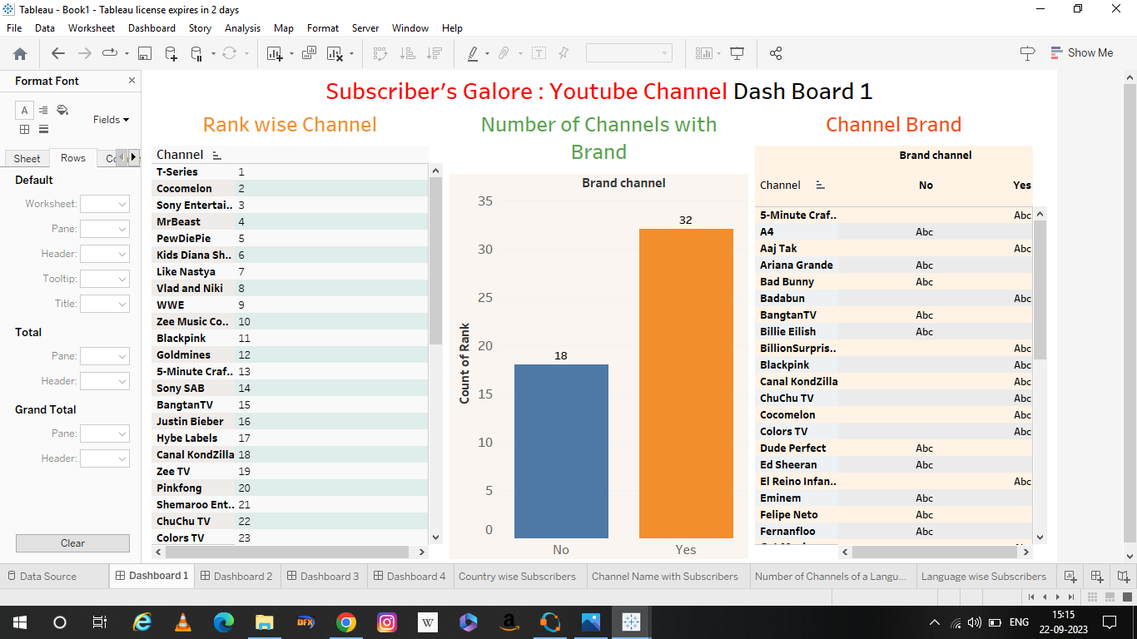

Dashboard 2:

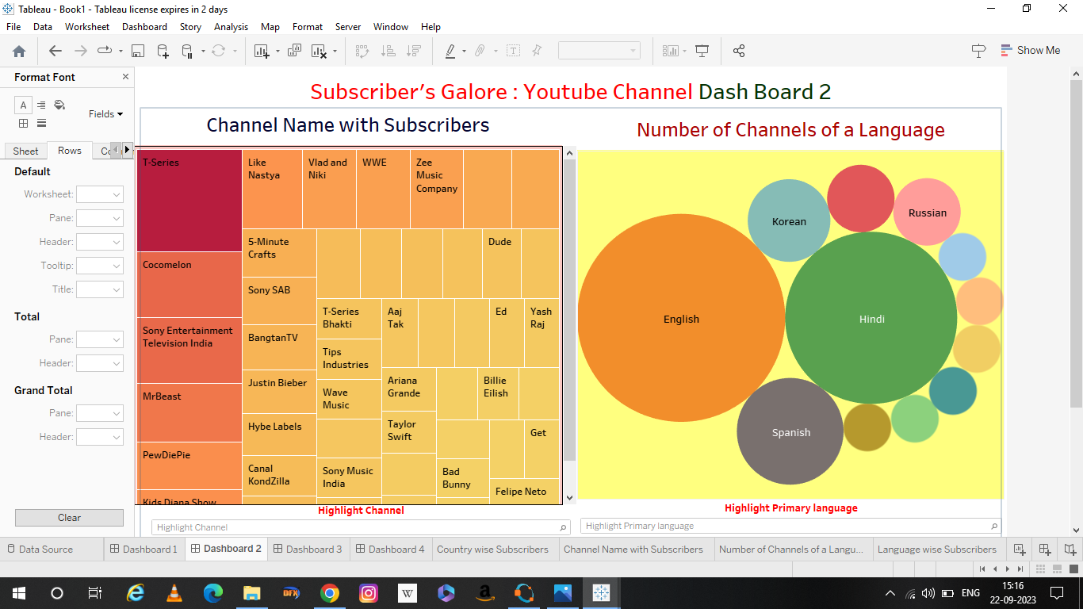

Dashboard 3:

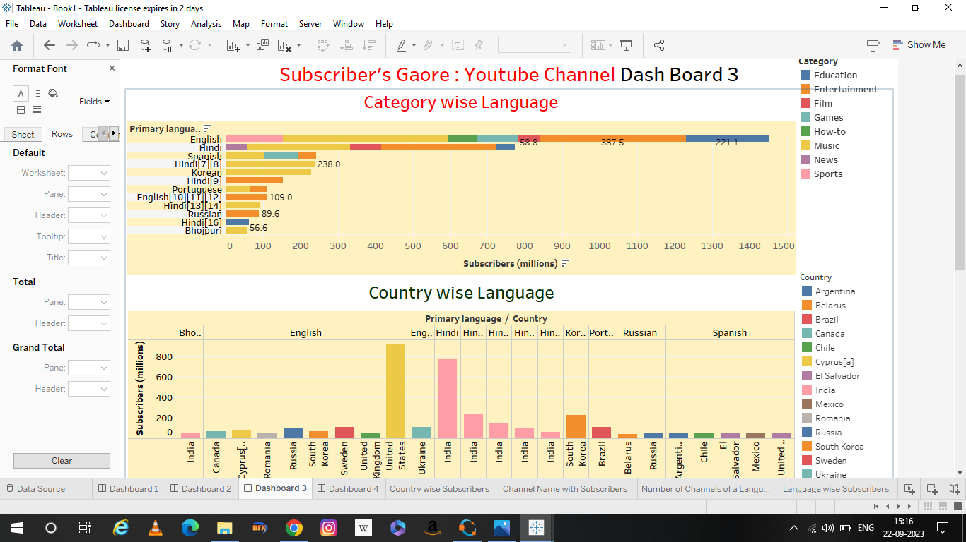

Dashboard 4:

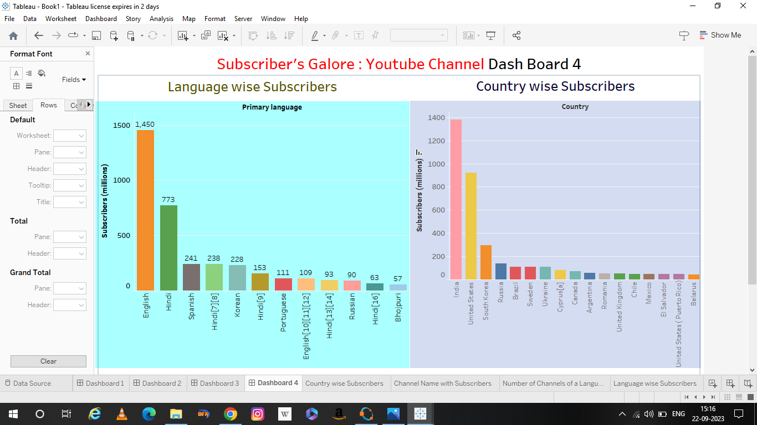

**Milestone 6:** **Story**

**Activity 1: No of scenes of story**

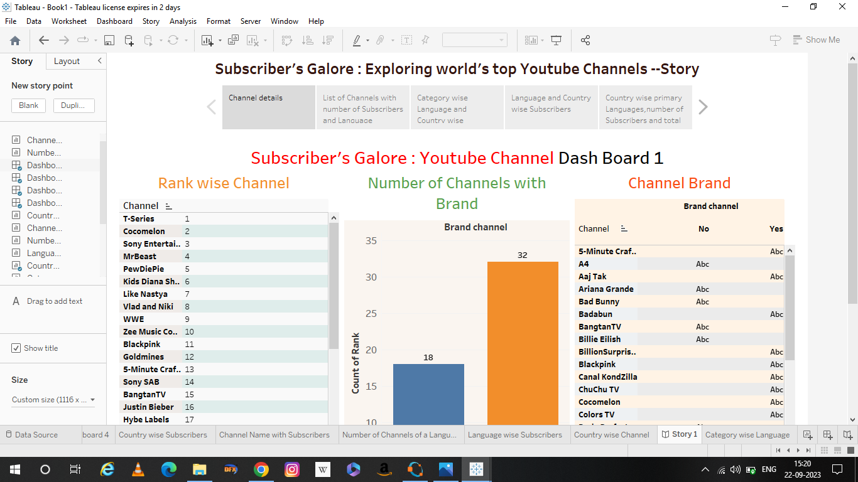

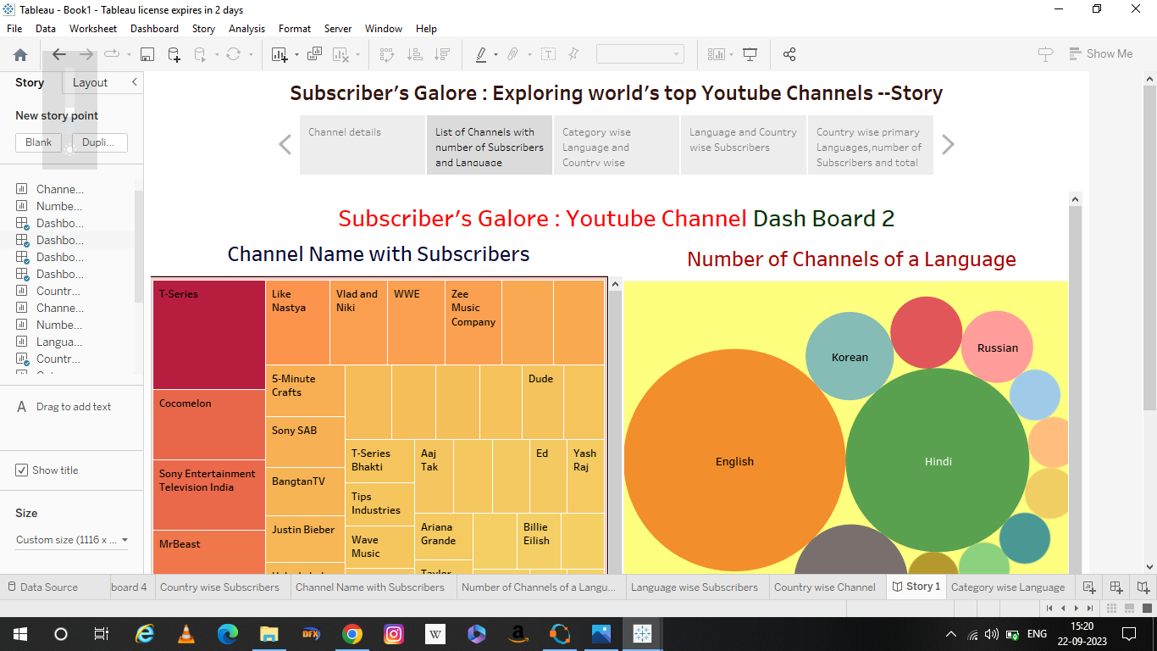

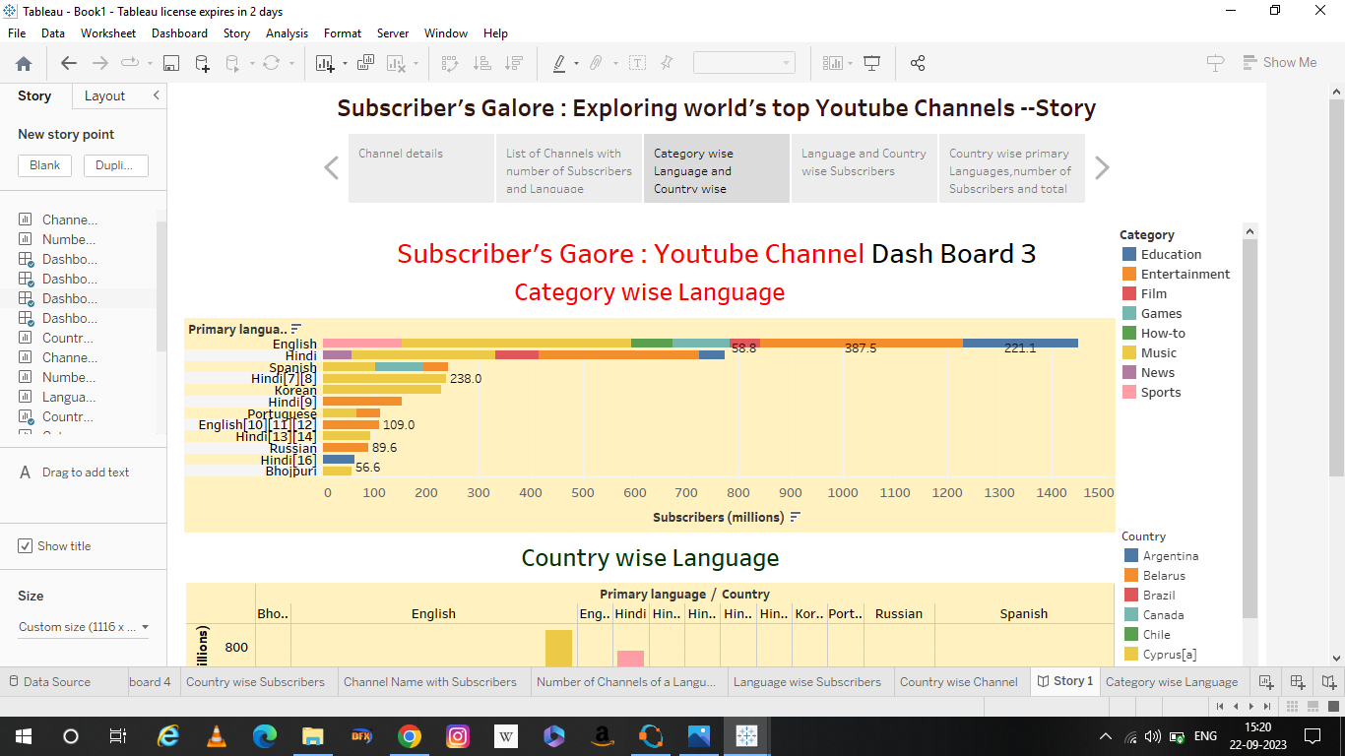

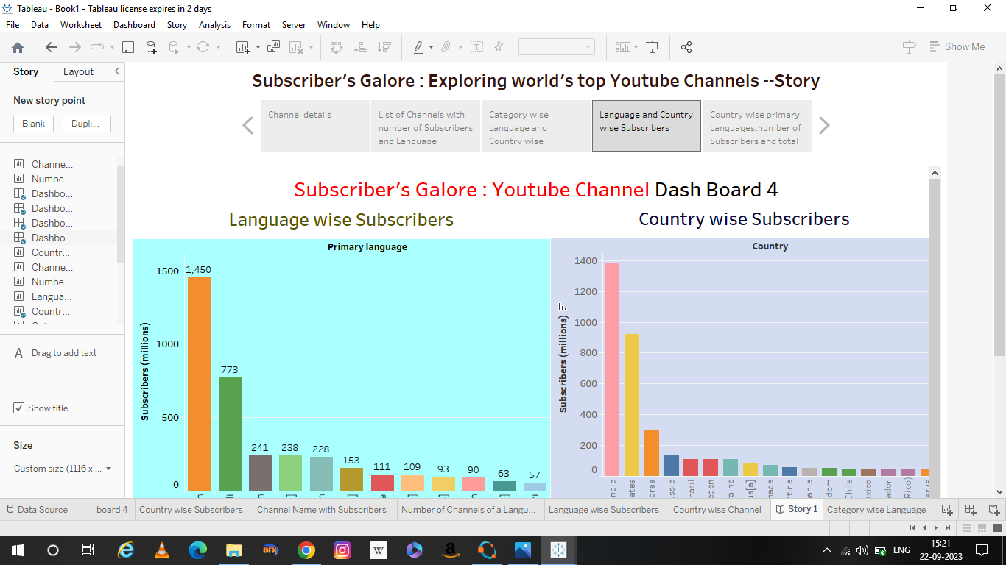

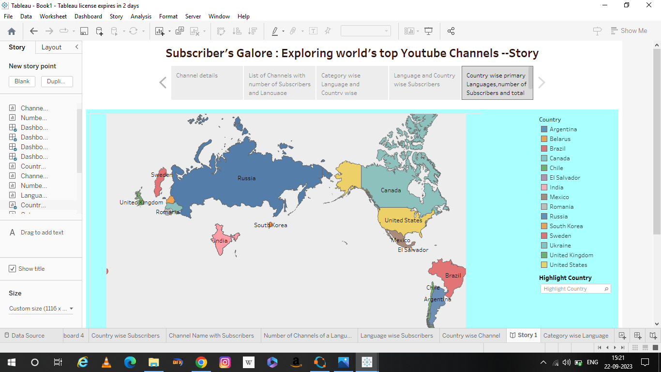

**Milestone 7:** **Performance Testing**

**Activity 1: Utilization of Filters**





**Milestone 8:** **Publishing**

**Dashboard 1:**

<https://public.tableau.com/views/NM2023TMID08464-Dashboard1/Dashboard1?:language=en-GB&:display_count=n&:origin=viz_share_link>

**Dashboard 2:**

<https://public.tableau.com/views/NM2023TMID08464-Dashboard2/Dashboard2?:language=en-GB&:display_count=n&:origin=viz_share_link>

**Dashboard 3:**

<https://public.tableau.com/views/NM2023TMID08464-Dashboard3/Dashboard3?:language=en-GB&:display_count=n&:origin=viz_share_link>

**Dashboard 4:**

<https://public.tableau.com/views/NM2023TMID08464-Dashboard4/Dashboard4?:language=en-GB&:display_count=n&:origin=viz_share_link>

**Story:**

<https://public.tableau.com/views/NM2023TMID08464-Story/Story1?:language=en-GB&:display_count=n&:origin=viz_share_link>

**Conclusion:**

* Since its launch in 2005, YouTube has been the go-to platform for entertainment. Whether you are in the mood for funny moments, news updates, or educational content, YouTube has it all.
* YouTube Marketing is the process of promoting your business on YouTube through videos and ads. Because video is an extremely powerful medium, YouTube is growing faster than any other platform out there.
* If a picture speaks a thousand words, a video makes up for million words. Moreover, videos can evoke emotion more than any other form of content.
* YouTube provides every business with an insane opportunity to get more traffic and customers. However, it is also a very competitive place as well. This means that you cannot just start uploading videos and expect see results overnight.